**Practical-9**

**AJAX Example 1:-**

**Code-**

<!doctype html>

<html lang="en">

  <head>

    <!-- Required meta tags -->

    <meta charset="utf-8">

    <meta name="viewport" content="width=device-width, initial-scale=1, shrink-to-fit=no">

    <!-- Bootstrap CSS -->

    <link rel="stylesheet" href="https://stackpath.bootstrapcdn.com/bootstrap/4.4.1/css/bootstrap.min.css" integrity="sha384-Vkoo8x4CGsO3+Hhxv8T/Q5PaXtkKtu6ug5TOeNV6gBiFeWPGFN9MuhOf23Q9Ifjh" crossorigin="anonymous">

    <title>First AJAX Demo</title>

  </head>

  <body>

    <h1>AJAX Tutorial</h1>

    <button type="button" id='fetchBtn' class="btn btn-primary">Fetch Data</button>

    <button type="button" id='BackupBtn' class="btn btn-secondary">Backup Button</button>

    <!-- Optional JavaScript -->

    <!-- jQuery first, then Popper.js, then Bootstrap JS -->

    <script src="https://code.jquery.com/jquery-3.4.1.slim.min.js" integrity="sha384-J6qa4849blE2+poT4WnyKhv5vZF5SrPo0iEjwBvKU7imGFAV0wwj1yYfoRSJoZ+n" crossorigin="anonymous"></script>

    <script src="https://cdn.jsdelivr.net/npm/popper.js@1.16.0/dist/umd/popper.min.js" integrity="sha384-Q6E9RHvbIyZFJoft+2mJbHaEWldlvI9IOYy5n3zV9zzTtmI3UksdQRVvoxMfooAo" crossorigin="anonymous"></script>

    <script src="https://stackpath.bootstrapcdn.com/bootstrap/4.4.1/js/bootstrap.min.js" integrity="sha384-wfSDF2E50Y2D1uUdj0O3uMBJnjuUD4Ih7YwaYd1iqfktj0Uod8GCExl3Og8ifwB6" crossorigin="anonymous"></script>

    <script src="first_sample.js"></script>

  </body>

</html>

console.log('Ajax demo')

var fetchBtn = document.getElementById("fetchBtn");

fetchBtn.addEventListener('click',buttonClickListener);

function buttonClickListener(){

    console.log("You have clicked");

    const xhr = new XMLHttpRequest();

    //Open the object

    xhr.open('GET','sample.txt',true); // True for asynchronous

    xhr.onprogress = function(){

        console.log("Data retrieval is in progress");

    }

    xhr.onreadystatechange = function(){ // ready state code values in xhr

        console.log('ready state is: ',xhr.readyState);

    }

    xhr.onload = function(){

        console.log(this.response);

    }

    xhr.send();

    console.log('done');

}

**Output-**

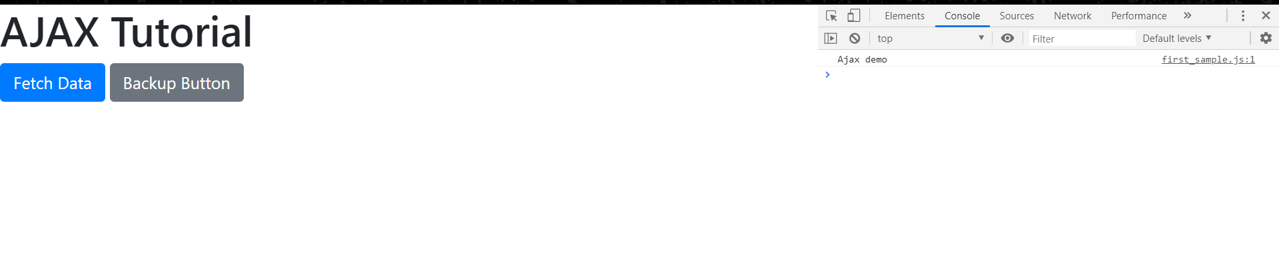

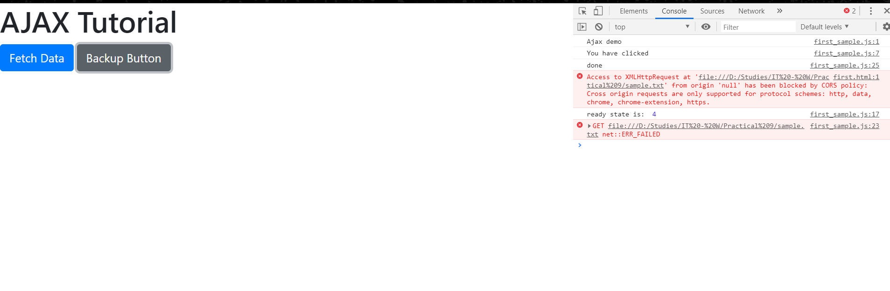

**Example 2:-**

**Code-**

<!doctype html>

<html lang="en">

  <head>

    <!-- Required meta tags -->

    <meta charset="utf-8">

    <meta name="viewport" content="width=device-width, initial-scale=1, shrink-to-fit=no">

    <!-- Bootstrap CSS -->

    <link rel="stylesheet" href="https://stackpath.bootstrapcdn.com/bootstrap/4.4.1/css/bootstrap.min.css" integrity="sha384-Vkoo8x4CGsO3+Hhxv8T/Q5PaXtkKtu6ug5TOeNV6gBiFeWPGFN9MuhOf23Q9Ifjh" crossorigin="anonymous">

    <title>Reading Json Data</title>

  </head>

  <body>

    <h1>This is demo to read JSON Data</h1>

    <h1>Click button to retrieve Animal Data</h1>

    <button type="button" id='fetchBtn' class="btn btn-primary">Fetch Data</button>

    <div id="animal_info"></div>

    <!-- Optional JavaScript -->

    <!-- jQuery first, then Popper.js, then Bootstrap JS -->

    <script src="https://code.jquery.com/jquery-3.4.1.slim.min.js" integrity="sha384-J6qa4849blE2+poT4WnyKhv5vZF5SrPo0iEjwBvKU7imGFAV0wwj1yYfoRSJoZ+n" crossorigin="anonymous"></script>

    <script src="https://cdn.jsdelivr.net/npm/popper.js@1.16.0/dist/umd/popper.min.js" integrity="sha384-Q6E9RHvbIyZFJoft+2mJbHaEWldlvI9IOYy5n3zV9zzTtmI3UksdQRVvoxMfooAo" crossorigin="anonymous"></script>

    <script src="https://stackpath.bootstrapcdn.com/bootstrap/4.4.1/js/bootstrap.min.js" integrity="sha384-wfSDF2E50Y2D1uUdj0O3uMBJnjuUD4Ih7YwaYd1iqfktj0Uod8GCExl3Og8ifwB6" crossorigin="anonymous"></script>

    <script src="second_json.js"></script>

  </body>

</html>

var count = 1;

var animal_data = document.getElementById("animal_info");

var btn = document.getElementById("fetchBtn");

console.log('2nd Java script');

btn.addEventListener('click',function(){

    var vReq = new XMLHttpRequest();

    vReq.open('GET','https://learnwebcode.github.io/json-example/animals-' + count + '.json');

    vReq.onload = function(){

    var ourData = JSON.parse(vReq.responseText);

    //console.log(ourData);

    fun_call(ourData);

    };

    vReq.send();

    count++;

    if(count > 3)

    {

        btn.classList.add("hide-me");

    }

});

function fun_call(data){

    var str="";

    for(i=0;i<data.length;i++)

    {

        str += "<p>" + data[i].name + " is a "+data[i].species +".</p>";

    }

    animal_data.insertAdjacentHTML('beforeend',str);

}

**Output-**

